**PH170:** Waves and Electromagnetics

**LAB 1**

Visualizations and plotting’s of Vector fields, divergence and curl.

**Name: Snehal Keshav Nalawade**

**ID: 202151160**

**Theory**

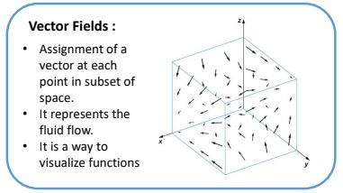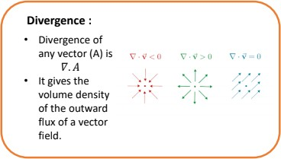

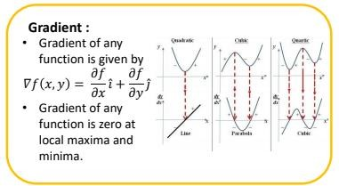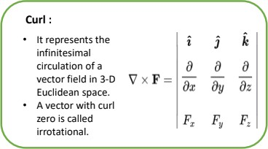

# Q2

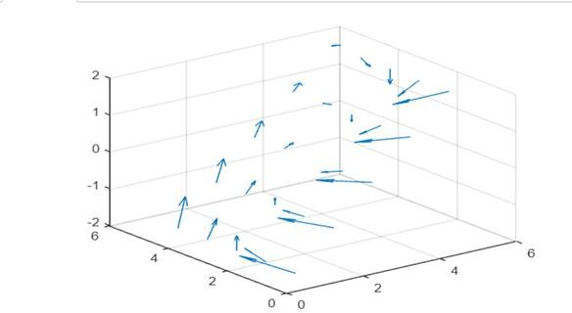[X,Y] = meshgrid(-2:2); U = Y.^2;

V = -X;

scale_factor=0.5; figure;quiver3(X,Y,U*scale_factor,V*scale_factor)

%figure;quiver3(X,Y,U*scale_factor,V*scale_factor,'AutoScale','off’)

X = 3;

Y = 2;

U = Y.^2; V = -X;

val = sqrt(U.^2 + V.^2)

## Output

Val = 5

## Q3

[X,Y] = meshgrid(0:pi); U = sin(X);

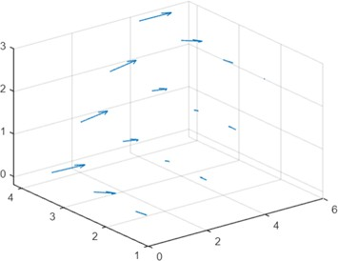V = -sin(Y);

%scale_factor = 1; figure;quiver3(X,Y,U*scale_factor,V*scale_factor)

%figure;quiver3(X,Y,U*scale_factor,V*scale_factor,'AutoScale','off’)

X = pi/2; Y = pi/2;

U = sin(X);

V = -sin(Y);

val = sqrt(U.^2 + V.^2)

## Output

Val = 1.4142

## Q4

clear

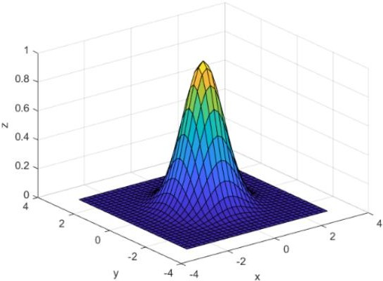x = -3:0.2:3;

y = x';

f = exp(-x.^2 - y.^2); surf(x,y,f)

xlabel('x')

ylabel('y')

zlabel('z')

[fx,fy] = gradient(f,0.2); x0 = 0;

y0 =0;

t = (x == x0) & (y == y0); indt = find(t);

gradient = [fx(indt),fy(indt)]

## Output

gradient =

0 0

**Q4 a)**

syms x y z;

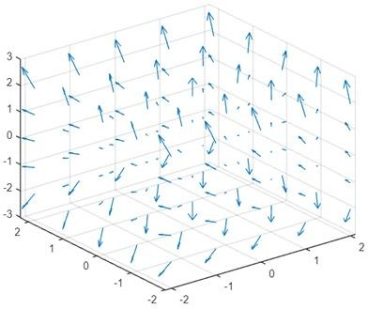F = x.^2 + y.^3 + z.^4; G = gradient(F)

[x,y,z] = meshgrid(-2:2);

U = 2*x;

V = 3*(y.^2);

W = 4*(z.^3);

figure;

scale_factor = 1; quiver3(x,y,z,U*scale_factor,V*scale_factor,W*scale_factor);

# Output

G =

2*x 3*y^2

4*z^3

## Q4 b)

syms x y z;

F = x.^2 * y.^3 * z.^4;

G = gradient(F)

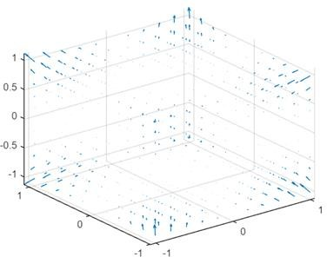[x,y,z] = meshgrid(-1:0.2:1);

U = 2*x .* y.^3 .* z.^4;

V = 3*x.^2 .* y.^2 .* z.^4; W = 4*x.^2 .* y.^3 .* z.^3; figure;

scale_factor = 1;

quiver3(x,y,z,U*scale_factor,V*scale_factor,W*scale_factor);

## Output

G=

2*x*y^3*z^4

3*x^2*y^2*z^4

4*x^2*y^3*z^3

# Q4 C)

syms x y z;

F = exp(x)*sin(y)*log(z);

G = gradient

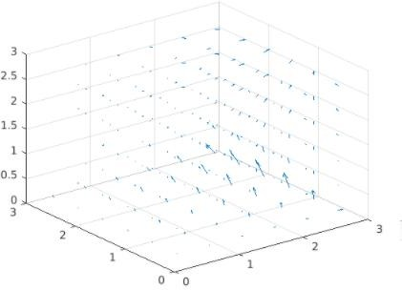(F)[x,y,z] = meshgrid(0:0.5:pi);

U = exp(x).*sin(y).*log(z);

V = exp(x).*cos(y).*log(z);

W = exp(x).*sin(y)./z;

figure;scale_factor = 1; quiver3(x,y,z,U*scale_factor,V*scale_factor,W*scale_factor);

## Output

G =

ex log(z)sin(y) ex cos(y)log(z) ex sin(y)/z

# Q5 a)

[x,y,z] = meshgrid(-2:2); U = x.^2;

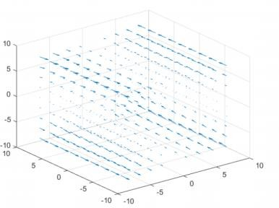V = 3.x.(z.^2);

W = -2.*x.*z; figure; scale_factor = 1;

quiver3(x,y,z,U*scale_factor,V*scale_factor,W*scale_factor)

%quiver3(x,y,z,U*scale_factor,V*scale_factor,W*scale_factor,'AutoScale','off’);

syms x y z;field = [ x.^2 3.x.(z.^2) -2.*x.*z];

vars = [x y z];

D = divergence(field,vars) C = curl(field,vars);

## Output

D = 0

## Q5 b)

syms x y z

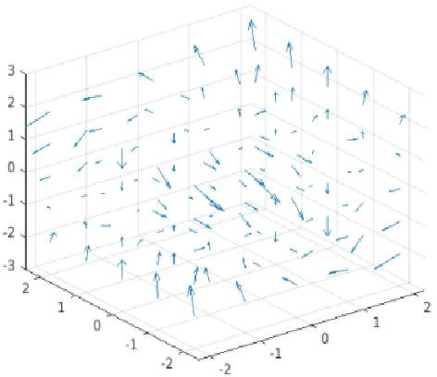field = [x.*y 2.*y.*z 3.*z.*x]; vars = [x y z]; divergence(field,vars)

[x,y,z] = meshgrid(-8:2:8, -8:2:8, -8:2:8);

Fx = x.*y;

Fy = 2.*y.*z; Fz = 3.*z.*x;

quiver3(x,y,z,Fx,Fy,Fz)

D = divergence(x,y,z,Fx,Fy,Fz);

## Output

D = 3x + y + 2z

## Q5 C)

syms x y z

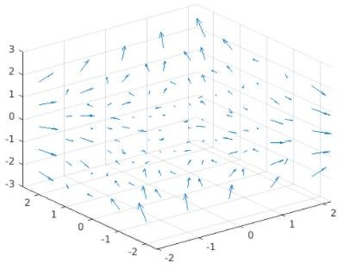field = [y.^2 2.*x.*y+z.^2 2.*y.*z]; vars = [x y z];

divergence(field,vars)

[x,y,z] = meshgrid(-8:2:8, -8:2:8, -8:2:8);

Fx = y.^2;

Fy = 2.*x.*y + z.^2; Fz = 2.*y.*z;

quiver3(x,y,z,Fx,Fy,Fz);

D = divergence(x,y,z,Fx,Fy,Fz);

## Output

D = 2x + 2y

## Q6 a)

syms x y z

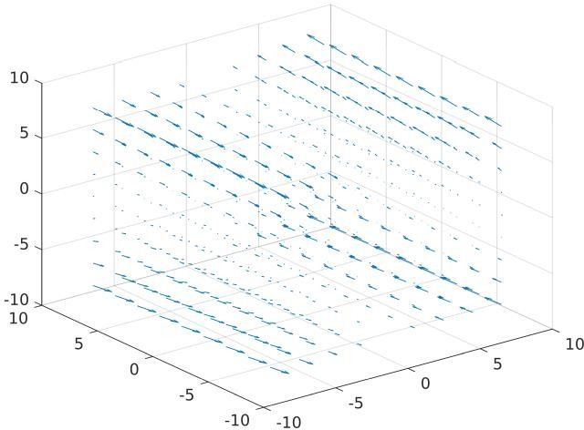a = [x.^2 3*x*z.^2 -2*x*z];

b = [x y z];

curl(a,b)

[x,y,z] = meshgrid(-8:2:8, -8:2:8, -8:2:8);

Fx = x.^2;

Fy = 3.*x.*z.^2;

Fz = 2.*x.*z; quiver3(x,y,z,Fx,Fy,Fz);

D = curl(x,y,z,Fx,Fy,Fz);

## Output

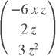Curl =

## Q6 b)

syms x y z

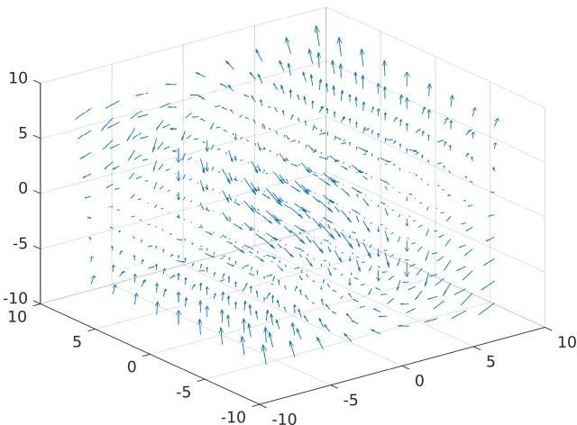field = [x.*y 2.*y.*z 3.*z.*x]; vars = [x y z];

curl(field,vars)

[x,y,z] = meshgrid(-8:2:8, -8:2:8, -8:2:8);

Fx = x.*y;

Fy = 2.*y.*z; Fz = 3.*z.*x;

quiver3(x,y,z,Fx,Fy,Fz)

D = curl(x,y,z,Fx,Fy,Fz);

## Output

Curl =

## Q6 c)

syms x y z

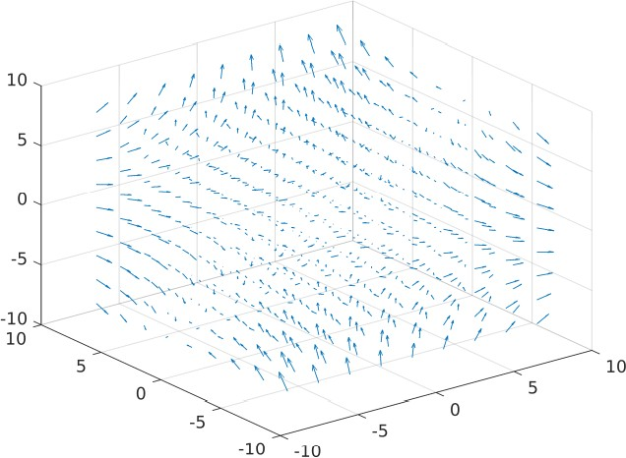field = [y.^2 2.*x.*y+z.^2 2.*y.*z]; vars = [x y z];

curl(field,vars)

[x,y,z] = meshgrid(-8:2:8,-8:2:8,-8:2:8);

Fx = y.^2;

Fy = 2.*x.*y + z.^2; Fz = 2.*y.*z; quiver3(x,y,z,Fx,Fy,Fz)

D = curl(x,y,z,Fx,Fy,Fz);

## Output

Curl =

## Q7

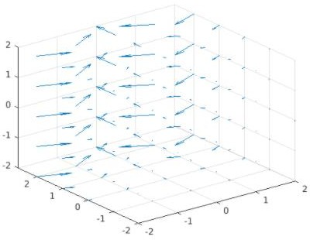syms x y z

field = [(-exp(y)*sin(x)) (exp(y)*cos(x)) 0]; vars = [x y z];

D = divergence(field,vars) C = curl(field,vars)

disp("plotting vector field") [x,y,z] = meshgrid(-2:2);

U = (-exp(y).*sin(x));

V = (exp(y).*cos(x)); W = z*0;

figure;

scale_factor = 1; quiver3(x,y,z,U*scale_factor,V*scale_factor,W*scale_factor);

%quiver3(x,y,z,U*scale_factor,V*scale_factor,W*scale_factor,'AutoScale','off');

***F =*** *(-exp(y)*sin(x))(x^) + (exp(y)*cos(x))(y^) + 0 (z^)*

***Thank You***